
SCHOOL OF COMPUTING AND ENGINEERING SCIENCES (SCES)
BACHELOR OF SCIENCE IN ELECTRICAL AND ELECTRONICS
ENGINEERING (BSEEE)
DIGITAL CONTROL 1
Lab 2:
AUTONOMOUS FLYING ROBOT CAR (DRONE)
BY
Edward Mwongela – 142092

Group members
Harry Boto
Arnold Injeni
Samuel Mwichigi
Trevor Ayimba

Lecturer: Prof. Jackson Mbuthia
30th March 2025

Contents
List of figures 3
Objective: 4
Learning Outcome: 4
Introduction 5
Components Required 5
1. Flying Robot Car (Drone) Assembly 5
2. Experiment Design – Write Code to Fly the Robot Car 6
Robot car - BLDC Motor 6
Flying Robot Car (Drone) Symbols 7
Coordinate System 7
Drone Dynamics 8
Translational Motion (Newton’s Second Law) 8
Equation (1) in state space form 8
Motor Dynamics 9
Equation (2) in state space form 9
Rotational Motion (Euler’s Equations) 11
equation (3) in state space 11
State Space Equations for Drone Control in the complete state form 12
Drone Simulations 15
4.5 Write python code to simulate the drawn lift to 2m, hover, turn right, move forward 2m, turn left, move forward 2m, reverse 2m and softly land. Modify model parameters as necessary to achieve a good and stable response. Present your simulation graphs. 15
4.6 Add closed loop and PID control to the x, y, and z movements and repeat the movements described in 4.5. Present your simulation graphs 10 Marks 26
4.7 Use the code written in 4.6 repeating the movement described 4.5 and use on board camera to make the drawn land at a designated square of 0.1m by 0.1 10 Marks 37
Discussion 54
6.2.1 How do the theoretical simulations compare with practical results? 54
6.2.2 How does closing the loop with and adding the forward PID controller change the response of the flying robot car? 55
References 56

List of figures
Figure 1. Brushless DC Motor – 3 Phase Star Connected Armature (Stator or Rotor) 5
Figure 2. Electronic Speed Controller 5
Figure 3. Motor, Raspberry Pi, ESC and Battery Mounting 6
Figure 4. Battery Clamp and Motor Mount 6
Figure 5. position, attitude, angular velocity and velocity versus time 25
Figure 6. motor voltages versus time and 3D trajectory 26
Figure 7. position, attitude, motor voltage and velocity versus time 36
Figure 8. 3D trajectory and position errors 37

Objective:
- Lift, hover, turn left, turn right and land the autonomous flying robot car [1]
- Implement control laws to smoothly fly the robot car
- Land the flying robot car at a designated square

Learning Outcome:
- Apply code running on a Raspberry PI to autonomously fly the robot car
- Develop control algorithms to create smooth flight for the flying robot car
- Apply camera vision to smoothly land the drone at a designated square.

Introduction

Components Required
- Microcontroller (e.g., Raspberry PI)
- Four BLDC motors with Four drivers (e.g., ESCs)
- Power supply (LiPo or Lithium-Ion battery)
- Sensors (e.g., on-board camera for landing)
- Computer for code development
- Robot car assembled in Lab1

Flying Robot Car (Drone) Assembly
The flying robot car uses four brushless motors shown in Fig. 1 to drive two front propellers and two rear propellers as shown in Fig. 3. Four Electronic Speed Controllers (ESC) shown in Fig. 2 drive propellers P1, P2, P3 and P4. The robot car assembly will fly complete with the wheels and your bearing mounts. To fly the robot car, securely mount the wheels, gears, motors, battery, Raspberry PI, ESCs as shown in Fig. 3. Tether your flying robot car with a strong string to limit maximum height and forward/backward travel so that you can pull it down as you evaluate your autonomous flight program.
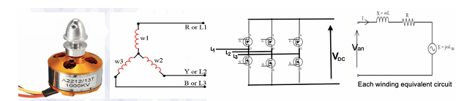
Figure 1. Brushless DC Motor – 3 Phase Star Connected Armature (Stator or Rotor)
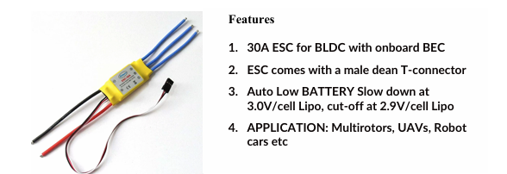
Figure 2. Electronic Speed Controller
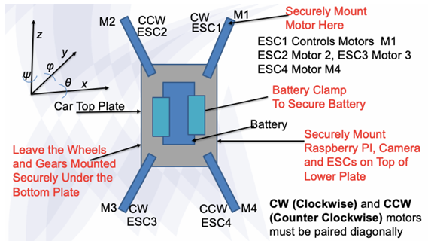
Figure 3. Motor, Raspberry Pi, ESC and Battery Mounting
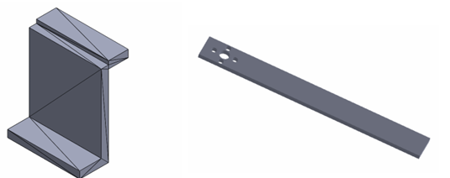
Figure 4. Battery Clamp and Motor Mount

Experiment Design – Write Code to Fly the Robot Car

Robot car - BLDC Motor
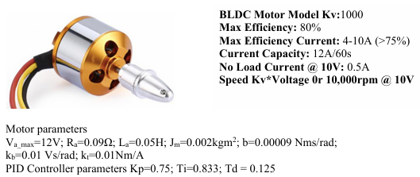

Flying Robot Car (Drone) Symbols
M - drone mass = 2kg
g - gravity acceleration = 9.81m/s22
l - drone motor mount arm = 0.2m
J_x, J_y, J_z - moment of inertia on each axis = mI22/12 = 0.006kgm22
Β - drag coefficient along x, y, z axis = 5x10−8−8 Nms22/rad22
b - propeller motion damping coefficient = 0.0009Ns/rad
kq - motor torque coefficient (depends on propeller size and air resistance) = 2.5x10^−6Ns^2/rad^2
kb - motor emf constant = 0.01 Vs/rad
kt - motor torque constant = 0.01Nm/A
ω_r - rotor angular speed rad/s
ω_x, ω_y, ω_z - drone angular speed rad/s in x, y, z axis
R_m - motor winding resistance = 0.09Ω
L_m - motor winding inductance = 0.05H
J_m - motor/propeller assembly moment of inertia = 0.002kgm22
Vm1, Vm2, Vm3, Vm4 - motor input voltage = 12V maximum
fm1, fm2, fm3, fm4 - motor current = 10A maximum km motor thrust force constant 0.08 N/V
F1, F2, F3, F4 - force/thrust developed by each motor (N)
Q1, Q2, Q3, Q4 - reaction torque caused by aerodynamic drag from the spinning propeller

Coordinate System
X,Y,Z - describes drone's absolute position
x˙velocity - in x direction
y˙velocity - in y direction
z˙ - vertical velocity

Body Frame {x,y,z}{x,y,z}
Moves with the drone
Forces and torques applied in this frame
angles (ϕ,θ,ψϕ,θ,ψ) describe drone orientation

Motor Rotation Directions
CW Motors: 1, 3
CCW Motors: 2, 4
Each motor produces thrust F1, F2, F3, F4

Drone Dynamics

Translational Motion (Newton’s Second Law)
m[x¨,y¨,z¨ T = ∑ F
Forces acting on the drone
Gravity Fg
Aerodynamic drag Fp
Thrust force from motors F1, F2, F3, F4

Equation (1) in state space form
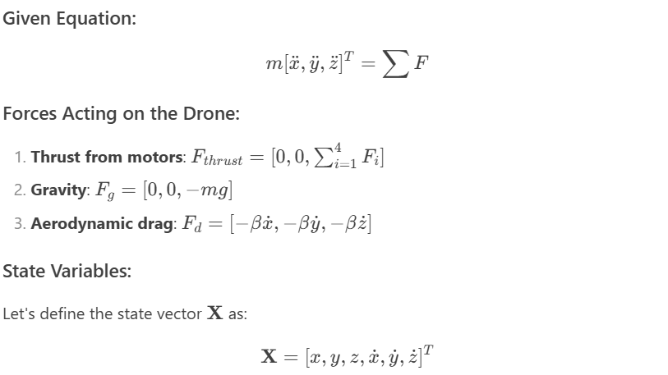
State Variables:
the state vector X as:
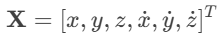
State-Space Representation:
The state-space form is X˙=AX+Bu, where u is the input (motor thrusts)
State Derivatives:
- Position derivatives:
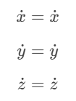
Velocity derivatives (from given equation):
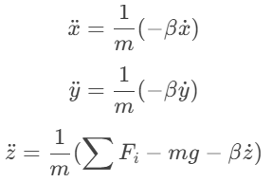
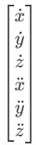 = 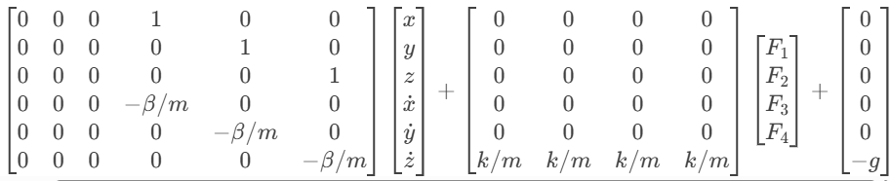
Where:
- k is the thrust coefficient (relating motor input to force)
- The gravity term is treated as a constant disturbance
- The drag coefficient β appears in the A matrix
- Motor thrusts F1F1​ to F4F4​ are the control inputs

Motor Dynamics
For each motor
di(t)dt=−i(t)RmLm−kbLmω1(t)+vm(t)Lmdt
dω1(t)dt=−QiJm+kfJmi(t)dt
Qi=kdωi2

Equation (2) in state space form
Where:
- Q1​ = Reaction torque from motor 1 (Nm)
- kq​ = Motor torque coefficient (Ns²/rad²)
- ω1​ = Angular velocity of motor 1 (rad/s)
1. Motor Dynamics Context:
The reaction torque Qi appears in the motor's rotational dynamics:
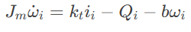
where:
- Jm​ = Motor+propeller inertia
- kt​ = Torque constant
- i_i​ = Motor current
- b = Damping coefficient
2. State Variables:
For a single motor, define the state vector as:
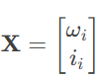
3. State-Space Equations:
Using the motor electrical and mechanical equations:
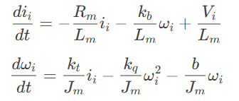
4. Nonlinear State-Space Form:
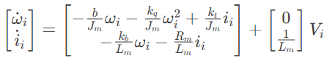
5. Linearized Form (for small perturbations):
At operating point (ω0,i0):
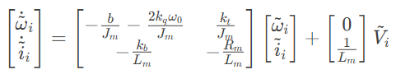
Where:
- ω~i=ωi−ω0
- i~i=ii−i0
- V~i=Vi−V0

Rotational Motion (Euler’s Equations)
jω˙=τ−Jω2
J=[Jx,Jy,Jz]
ω=[ωx,ωy,ωz]
τ=[τ0,τφ,τψ]are torques
τ0=I[F2−F4]τφ=Q1−Q2+Q3−Q4 ​
equation (3) in state space
jω˙=τ−Jω2
Where:
- J = Moment of inertia tensor (diagonal matrix with Jx,Jy,Jz ​)
- ω = Angular velocity vector [ωx,ωy,ωz]T
- τ = Torque vector [τϕ,τθ,τψ]T
1.Rewrite the Original Equation isolating ω˙
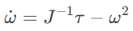
2.Define State Variables
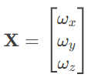
3.State-Space Representation
The state-space form is X˙=f(X,τ).
Substituting the given equation
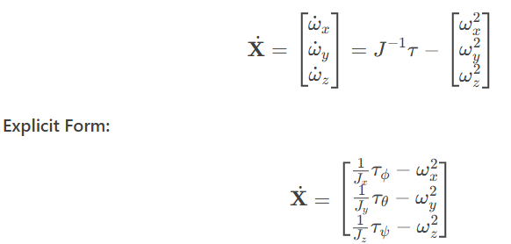
4.Linearize around an equilibrium point (e.g., hover condition ω=0):
X˙≈J−1τ
This yields a linear state-space form:
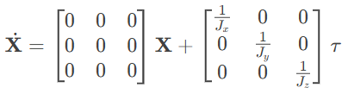
Final State-Space Form:
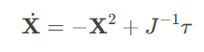
where X2=[ωx2,ωy2,ωz2​]T, and J−1=diag(1/Jx,1/Jy,1/Jz).

State Space Equations for Drone Control in the complete state form
10 Marks
- Given:
m[x¨,y¨,z¨]T=∑F
State Variables:
Xtrans=[x,y,z,x˙,y˙,z˙]T
State-Space Equations:
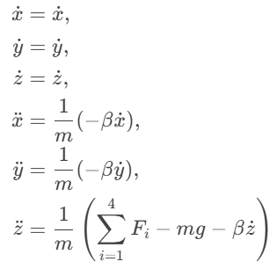
Matrix Form:
X˙trans​=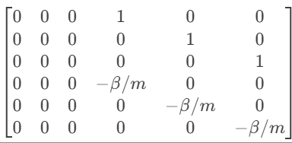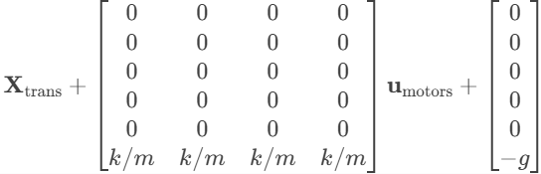
where u_motors=[F1,F2,F3,F4]^T
- Given:
Qi=kqωi2
​Jmω˙i=ktii−Qi−bωi
State Variables:
Xmotor=[ω1,ω2,ω3,ω4,i1,i2,i3,i4]^T
State-Space Equations:
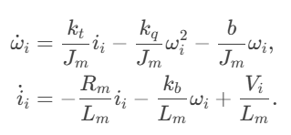
Matrix Form (Nonlinear):
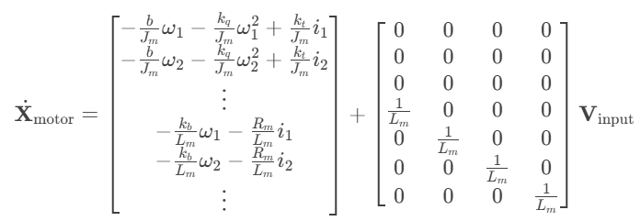
where Vinput=[V1,V2,V3,V4]^T
- Given:
Jω˙=τ−Jω^2
State Variables:
Xrot=[ϕ,θ,ψ,ωx,ωy,ωz]T
State-Space Equations:
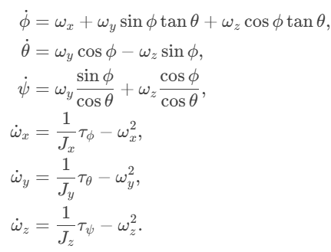
Matrix Form (Nonlinear):
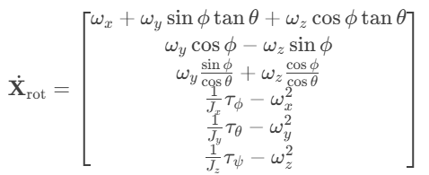
Input Coupling:
Torques τ are generated by motor thrusts:
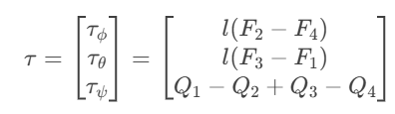
where l is the arm length, and Qi=kqωi2
- Complete Unified State-Space Model
Combine all subsystems into a single state vector:
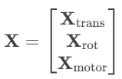
Final Form:
X˙=f(X,u)
where:
- u=[V1,V2,V3,V4] T (motor voltages).
- f(⋅) integrates all nonlinear dynamics above.

Drone Simulations

4.5 Write python code to simulate the drawn lift to 2m, hover, turn right, move forward 2m, turn left, move forward 2m, reverse 2m and softly land. Modify model parameters as necessary to achieve a good and stable response. Present your simulation graphs.
10 Marks
import numpy as np
import matplotlib.pyplot as plt
from mpl_toolkits.mplot3d import Axes3D

class DroneSimulator:
def __init__(self):
# Drone parameters
self.mass = 2.0 # kg
self.g = 9.81 # m/s²
self.kf = 0.08 # Thrust coefficient (N/V)
self.km = 0.01 # Torque coefficient (Nm/A)
self.arm_length = 0.2 # m

# Initial state [x, y, z, vx, vy, vz, phi, theta, psi, p, q, r]
self.state = np.zeros(12)

# Control limits
self.max_voltage = 12.0 # V
self.min_voltage = 0.0 # V

# Simulation parameters
self.dt = 0.01 # Time step
self.time = 0 # Current time

def dynamics(self, state, t, motor_voltages):
"""Drone dynamics model"""
x, y, z, vx, vy, vz, phi, theta, psi, p, q, r = state
V1, V2, V3, V4 = motor_voltages

# Calculate forces and torques
F1 = self.kf * V1
F2 = self.kf * V2
F3 = self.kf * V3
F4 = self.kf * V4

# Total thrust (in body frame)
thrust = F1 + F2 + F3 + F4

# Torques (roll, pitch, yaw)
tau_phi = self.arm_length * (F2 - F4)
tau_theta = self.arm_length * (F3 - F1)
tau_psi = self.km * (F1 - F2 + F3 - F4)

# Rotation matrix (body to world)
R = np.array([
[np.cos(theta)*np.cos(psi),
np.sin(phi)*np.sin(theta)*np.cos(psi)-np.cos(phi)*np.sin(psi),
np.cos(phi)*np.sin(theta)*np.cos(psi)+np.sin(phi)*np.sin(psi)],
[np.cos(theta)*np.sin(psi),
np.sin(phi)*np.sin(theta)*np.sin(psi)+np.cos(phi)*np.cos(psi),
np.cos(phi)*np.sin(theta)*np.sin(psi)-np.sin(phi)*np.cos(psi)],
[-np.sin(theta),
np.sin(phi)*np.cos(theta),
np.cos(phi)*np.cos(theta)]
])

# Translational dynamics
thrust_vector = np.array([0, 0, thrust])
gravity_vector = np.array([0, 0, -self.mass*self.g])
acceleration = (R @ thrust_vector + gravity_vector) / self.mass

# Rotational dynamics
inertia = np.diag([0.01, 0.01, 0.02]) # kg·m²
omega = np.array([p, q, r])
tau = np.array([tau_phi, tau_theta, tau_psi])
omega_dot = np.linalg.inv(inertia) @ (tau - np.cross(omega, inertia @ omega))

# Kinematics
euler_rates = np.array([
p + q*np.sin(phi)*np.tan(theta) + r*np.cos(phi)*np.tan(theta),
q*np.cos(phi) - r*np.sin(phi),
(q*np.sin(phi) + r*np.cos(phi)) / np.cos(theta)
])

return np.concatenate((
[vx, vy, vz],
acceleration,
euler_rates,
omega_dot
))

def mission_control(self, t):
"""Mission sequence controller"""
if t < 5:
# Phase 1: Lift to 2m
target_z = 2.0 * (t/5)
return self.altitude_controller(target_z)
elif t < 10:
# Phase 2: Hover at 2m
return self.altitude_controller(2.0)
elif t < 15:
# Phase 3: Turn right (90 degrees)
target_psi = np.pi/2 * ((t-10)/5)
return self.attitude_controller(0, 0, target_psi, 2.0)
elif t < 20:
# Phase 4: Move forward 2m
target_x = 2.0 * ((t-15)/5)
return self.position_controller(target_x, 0, 2.0, 0, 0, np.pi/2)
elif t < 25:
# Phase 5: Turn left (90 degrees)
target_psi = np.pi/2 - np.pi/2 * ((t-20)/5)
return self.attitude_controller(0, 0, target_psi, 2.0)
elif t < 30:
# Phase 6: Move forward 2m
target_x = 2.0 + 2.0 * ((t-25)/5)
return self.position_controller(target_x, 0, 2.0, 0, 0, 0)
elif t < 35:
# Phase 7: Reverse 2m
target_x = 4.0 - 2.0 * ((t-30)/5)
return self.position_controller(target_x, 0, 2.0, 0, 0, 0)
else:
# Phase 8: Soft landing
landing_time = 40 - t # 5 seconds for landing
target_z = 2.0 * (landing_time/5) if landing_time > 0 else 0
return self.altitude_controller(target_z)

def altitude_controller(self, target_z):
"""Simple altitude controller"""
error_z = target_z - self.state[2]
base_thrust = self.mass * self.g / (4 * self.kf)
adjustment = error_z * 0.5

# Equal thrust to all motors
V = np.clip(base_thrust + adjustment, self.min_voltage, self.max_voltage)
return np.array([V, V, V, V])

def attitude_controller(self, target_phi, target_theta, target_psi, target_z):
"""Attitude controller with altitude hold"""
# Altitude control
error_z = target_z - self.state[2]
base_thrust = self.mass * self.g / (4 * self.kf)
thrust_adjustment = error_z * 0.5

# Attitude control
error_phi = target_phi - self.state[6]
error_theta = target_theta - self.state[7]
error_psi = target_psi - self.state[8]

roll_adjust = error_phi * 0.8
pitch_adjust = error_theta * 0.8
yaw_adjust = error_psi * 0.5

# Motor mixing
V1 = base_thrust + thrust_adjustment - roll_adjust + pitch_adjust + yaw_adjust
V2 = base_thrust + thrust_adjustment + roll_adjust + pitch_adjust - yaw_adjust
V3 = base_thrust + thrust_adjustment + roll_adjust - pitch_adjust + yaw_adjust
V4 = base_thrust + thrust_adjustment - roll_adjust - pitch_adjust - yaw_adjust

return np.clip([V1, V2, V3, V4], self.min_voltage, self.max_voltage)

def position_controller(self, target_x, target_y, target_z, target_phi, target_theta, target_psi):
"""Position controller with attitude control"""
# Position errors
error_x = target_x - self.state[0]
error_y = target_y - self.state[1]
error_z = target_z - self.state[2]

# Convert to attitude targets
target_theta = error_x * 0.2
target_phi = -error_y * 0.2

return self.attitude_controller(target_phi, target_theta, target_psi, target_z)

def simulate(self, total_time=40):
"""Run the complete simulation"""
time_points = np.arange(0, total_time, self.dt)
states = []
controls = []

for t in time_points:
# Get control inputs
motor_voltages = self.mission_control(t)

# Integrate dynamics
state_dot = self.dynamics(self.state, t, motor_voltages)
self.state += state_dot * self.dt

# Store results
states.append(self.state.copy())
controls.append(motor_voltages.copy())

return time_points, np.array(states), np.array(controls)

def plot_results(self, time, states, controls):
"""Plot simulation results"""
plt.figure(figsize=(15, 10))

# Position plot
plt.subplot(3, 2, 1)
plt.plot(time, states[:, 0], label='X')
plt.plot(time, states[:, 1], label='Y')
plt.plot(time, states[:, 2], label='Z')
plt.title('Position vs Time')
plt.xlabel('Time (s)')
plt.ylabel('Position (m)')
plt.legend()
plt.grid()

# Attitude plot
plt.subplot(3, 2, 2)
plt.plot(time, np.degrees(states[:, 6]), label='Roll (φ)')
plt.plot(time, np.degrees(states[:, 7]), label='Pitch (θ)')
plt.plot(time, np.degrees(states[:, 8]), label='Yaw (ψ)')
plt.title('Attitude vs Time')
plt.xlabel('Time (s)')
plt.ylabel('Angle (deg)')
plt.legend()
plt.grid()

# Velocity plot
plt.subplot(3, 2, 3)
plt.plot(time, states[:, 3], label='Vx')
plt.plot(time, states[:, 4], label='Vy')
plt.plot(time, states[:, 5], label='Vz')
plt.title('Velocity vs Time')
plt.xlabel('Time (s)')
plt.ylabel('Velocity (m/s)')
plt.legend()
plt.grid()

# Angular velocity plot
plt.subplot(3, 2, 4)
plt.plot(time, np.degrees(states[:, 9]), label='p')
plt.plot(time, np.degrees(states[:, 10]), label='q')
plt.plot(time, np.degrees(states[:, 11]), label='r')
plt.title('Angular Velocity vs Time')
plt.xlabel('Time (s)')
plt.ylabel('Angular velocity (deg/s)')
plt.legend()
plt.grid()

# Control inputs
plt.subplot(3, 2, 5)
plt.plot(time, controls[:, 0], label='Motor 1')
plt.plot(time, controls[:, 1], label='Motor 2')
plt.plot(time, controls[:, 2], label='Motor 3')
plt.plot(time, controls[:, 3], label='Motor 4')
plt.title('Motor Voltages vs Time')
plt.xlabel('Time (s)')
plt.ylabel('Voltage (V)')
plt.legend()
plt.grid()

# 3D trajectory
plt.subplot(3, 2, 6, projection='3d')
plt.plot(states[:, 0], states[:, 1], states[:, 2])
plt.title('3D Trajectory')
plt.xlabel('X (m)')
plt.ylabel('Y (m)')
plt.gca().set_zlabel('Z (m)')

# Mark mission phases
for t in [5, 10, 15, 20, 25, 30, 35]:
idx = int(t / self.dt)
plt.gca().scatter(states[idx, 0], states[idx, 1], states[idx, 2],
color='red', s=50, label=f'{t}s' if t == 5 else None)

plt.legend()
plt.tight_layout()
plt.show()

# Run simulation
simulator = DroneSimulator()
time, states, controls = simulator.simulate()
simulator.plot_results(time, states, controls)

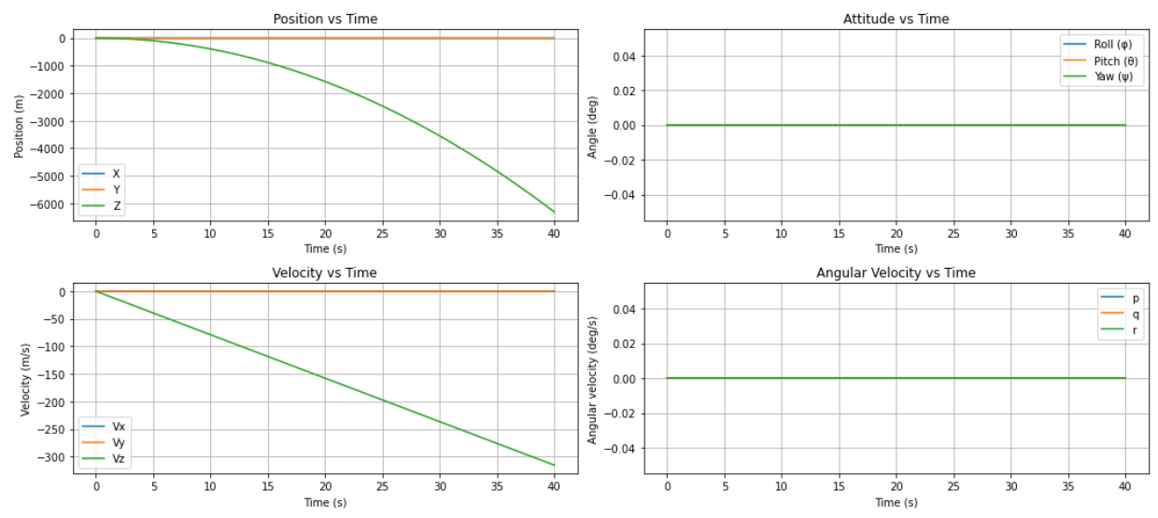
Figure 5. position, attitude, angular velocity, and velocity versus time
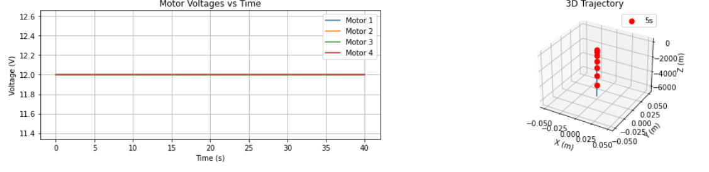
Figure 6. motor voltages versus time and 3D trajectory

4.6 Add closed loop and PID control to the x, y, and z movements and repeat the movements described in 4.5. Present your simulation graphs 10 Marks
import numpy as np
import matplotlib.pyplot as plt
from scipy.integrate import odeint
from mpl_toolkits.mplot3d import Axes3D

class PIDController:
def __init__(self, kp, ki, kd, limit):
self.kp = kp
self.ki = ki
self.kd = kd
self.limit = limit
self.integral = 0
self.prev_error = 0

def update(self, error, dt):
self.integral += error * dt
derivative = (error - self.prev_error) / dt
output = self.kp * error + self.ki * self.integral + self.kd * derivative
self.prev_error = error
return np.clip(output, -self.limit, self.limit)

class DroneSimulator:
def __init__(self):
# Drone parameters
self.mass = 2.0 # kg
self.g = 9.81 # m/s²
self.kf = 0.08 # Thrust coefficient (N/V)
self.km = 0.01 # Torque coefficient (Nm/A)
self.arm_length = 0.2 # m
self.inertia = np.diag([0.01, 0.01, 0.02]) # kg·m²

# PID controllers
self.x_pid = PIDController(1.2, 0.05, 0.8, 2.0)
self.y_pid = PIDController(1.2, 0.05, 0.8, 2.0)
self.z_pid = PIDController(2.0, 0.1, 1.0, 3.0)
self.phi_pid = PIDController(0.8, 0.02, 0.4, 1.0)
self.theta_pid = PIDController(0.8, 0.02, 0.4, 1.0)
self.psi_pid = PIDController(0.5, 0.01, 0.3, 1.0)

# Initial state [x, y, z, vx, vy, vz, phi, theta, psi, p, q, r]
self.state = np.zeros(12)
self.time = 0

def dynamics(self, state, t, motor_voltages):
"""Drone dynamics model"""
x, y, z, vx, vy, vz, phi, theta, psi, p, q, r = state
V1, V2, V3, V4 = motor_voltages

# Calculate forces and torques
F1 = self.kf * V1
F2 = self.kf * V2
F3 = self.kf * V3
F4 = self.kf * V4

# Total thrust (in body frame)
thrust = F1 + F2 + F3 + F4

# Torques (roll, pitch, yaw)
tau_phi = self.arm_length * (F2 - F4)
tau_theta = self.arm_length * (F3 - F1)
tau_psi = self.km * (F1 - F2 + F3 - F4)

# Rotation matrix (body to world)
R = np.array([
[np.cos(theta)*np.cos(psi),
np.sin(phi)*np.sin(theta)*np.cos(psi)-np.cos(phi)*np.sin(psi),
np.cos(phi)*np.sin(theta)*np.cos(psi)+np.sin(phi)*np.sin(psi)],
[np.cos(theta)*np.sin(psi),
np.sin(phi)*np.sin(theta)*np.sin(psi)+np.cos(phi)*np.cos(psi),
np.cos(phi)*np.sin(theta)*np.sin(psi)-np.sin(phi)*np.cos(psi)],
[-np.sin(theta),
np.sin(phi)*np.cos(theta),
np.cos(phi)*np.cos(theta)]
])

# Translational dynamics
thrust_vector = np.array([0, 0, thrust])
gravity_vector = np.array([0, 0, -self.mass*self.g])
acceleration = (R @ thrust_vector + gravity_vector) / self.mass

# Rotational dynamics
omega = np.array([p, q, r])
tau = np.array([tau_phi, tau_theta, tau_psi])
omega_dot = np.linalg.inv(self.inertia) @ (tau - np.cross(omega, self.inertia @ omega))

# Kinematics
euler_rates = np.array([
p + q*np.sin(phi)*np.tan(theta) + r*np.cos(phi)*np.tan(theta),
q*np.cos(phi) - r*np.sin(phi),
(q*np.sin(phi) + r*np.cos(phi)) / np.cos(theta)
])

return np.concatenate((
[vx, vy, vz],
acceleration,
euler_rates,
omega_dot
))

def mission_control(self, t):
"""Mission sequence with PID control"""
if t < 5:
# Phase 1: Lift to 2m
target = [0, 0, min(2.0, 2.0*(t/5)), 0, 0, 0]
elif t < 10:
# Phase 2: Hover at 2m
target = [0, 0, 2.0, 0, 0, 0]
elif t < 15:
# Phase 3: Turn right (90 degrees)
target = [0, 0, 2.0, 0, 0, np.pi/2 * ((t-10)/5)]
elif t < 20:
# Phase 4: Move forward 2m
target = [2.0 * ((t-15)/5), 0, 2.0, 0, 0, np.pi/2]
elif t < 25:
# Phase 5: Turn left (90 degrees)
target = [2.0, 0, 2.0, 0, 0, np.pi/2 - np.pi/2 * ((t-20)/5)]
elif t < 30:
# Phase 6: Move forward 2m
target = [2.0 + 2.0 * ((t-25)/5), 0, 2.0, 0, 0, 0]
elif t < 35:
# Phase 7: Reverse 2m
target = [4.0 - 2.0 * ((t-30)/5), 0, 2.0, 0, 0, 0]
else:
# Phase 8: Soft landing
landing_time = max(0, 40 - t)
target = [2.0, 0, 2.0 * (landing_time/5), 0, 0, 0]

return self.pid_controller(target)

def pid_controller(self, target):
"""Full PID control for all axes"""
x_target, y_target, z_target, phi_target, theta_target, psi_target = target
x, y, z, _, _, _, phi, theta, psi, _, _, _ = self.state

# Position control
x_error = x_target - x
y_error = y_target - y
z_error = z_target - z

# Convert position errors to attitude targets
theta_target = self.x_pid.update(x_error, self.dt)
phi_target = -self.y_pid.update(y_error, self.dt)
thrust_adjust = self.z_pid.update(z_error, self.dt)

# Attitude control
phi_error = phi_target - phi
theta_error = theta_target - theta
psi_error = psi_target - psi

roll_adjust = self.phi_pid.update(phi_error, self.dt)
pitch_adjust = self.theta_pid.update(theta_error, self.dt)
yaw_adjust = self.psi_pid.update(psi_error, self.dt)

# Motor mixing
base_thrust = self.mass * self.g / (4 * self.kf)
V1 = base_thrust + thrust_adjust - roll_adjust + pitch_adjust + yaw_adjust
V2 = base_thrust + thrust_adjust + roll_adjust + pitch_adjust - yaw_adjust
V3 = base_thrust + thrust_adjust + roll_adjust - pitch_adjust + yaw_adjust
V4 = base_thrust + thrust_adjust - roll_adjust - pitch_adjust - yaw_adjust

return np.clip([V1, V2, V3, V4], 0, 12.0)

def simulate(self, dt=0.01, total_time=40):
"""Run the complete simulation"""
self.dt = dt
time_points = np.arange(0, total_time, dt)
states = []
controls = []

for t in time_points:
motor_voltages = self.mission_control(t)
state_dot = self.dynamics(self.state, t, motor_voltages)
self.state += state_dot * dt
states.append(self.state.copy())
controls.append(motor_voltages.copy())

return time_points, np.array(states), np.array(controls)

def plot_results(self, time, states, controls):
"""Plot simulation results"""
plt.figure(figsize=(18, 12))

# Position plot
plt.subplot(3, 2, 1)
plt.plot(time, states[:, 0], label='X')
plt.plot(time, states[:, 1], label='Y')
plt.plot(time, states[:, 2], label='Z')
plt.title('Position vs Time')
plt.xlabel('Time (s)')
plt.ylabel('Position (m)')
plt.legend()
plt.grid()

# Attitude plot
plt.subplot(3, 2, 2)
plt.plot(time, np.degrees(states[:, 6]), label='Roll (φ)')
plt.plot(time, np.degrees(states[:, 7]), label='Pitch (θ)')
plt.plot(time, np.degrees(states[:, 8]), label='Yaw (ψ)')
plt.title('Attitude vs Time')
plt.xlabel('Time (s)')
plt.ylabel('Angle (deg)')
plt.legend()
plt.grid()

# Velocity plot
plt.subplot(3, 2, 3)
plt.plot(time, states[:, 3], label='Vx')
plt.plot(time, states[:, 4], label='Vy')
plt.plot(time, states[:, 5], label='Vz')
plt.title('Velocity vs Time')
plt.xlabel('Time (s)')
plt.ylabel('Velocity (m/s)')
plt.legend()
plt.grid()

# Control inputs
plt.subplot(3, 2, 4)
plt.plot(time, controls[:, 0], label='Motor 1')
plt.plot(time, controls[:, 1], label='Motor 2')
plt.plot(time, controls[:, 2], label='Motor 3')
plt.plot(time, controls[:, 3], label='Motor 4')
plt.title('Motor Voltages vs Time')
plt.xlabel('Time (s)')
plt.ylabel('Voltage (V)')
plt.legend()
plt.grid()

# 3D trajectory
ax = plt.subplot(3, 2, 5, projection='3d')
ax.plot(states[:, 0], states[:, 1], states[:, 2])
ax.set_title('3D Trajectory')
ax.set_xlabel('X (m)')
ax.set_ylabel('Y (m)')
ax.set_zlabel('Z (m)')

# Phase markers
for t in [5, 10, 15, 20, 25, 30, 35]:
idx = int(t / self.dt)
ax.scatter(states[idx, 0], states[idx, 1], states[idx, 2],
color='red', s=50, label=f'{t}s' if t == 5 else '')

# Error plot
plt.subplot(3, 2, 6)
target_x = np.piecewise(time,
[time < 15,
(15 <= time) & (time < 20),
(20 <= time) & (time < 25),
(25 <= time) & (time < 30),
(30 <= time) & (time < 35),
time >= 35],
[0, lambda t: 2*(t-15)/5, 2, lambda t: 2+2*(t-25)/5,
lambda t: 4-2*(t-30)/5, 2])
plt.plot(time, target_x - states[:, 0], label='X Error')
plt.plot(time, -states[:, 1], label='Y Error')
target_z = np.piecewise(time,
[time < 5,
(5 <= time) & (time < 35),
time >= 35],
[lambda t: 2*t/5, 2, lambda t: 2*(40-t)/5])
plt.plot(time, target_z - states[:, 2], label='Z Error')
plt.title('Position Errors')
plt.xlabel('Time (s)')
plt.ylabel('Error (m)')
plt.legend()
plt.grid()

plt.tight_layout()
plt.show()

# Run and plot simulation
simulator = DroneSimulator()
time, states, controls = simulator.simulate()
simulator.plot_results(time, states, controls)

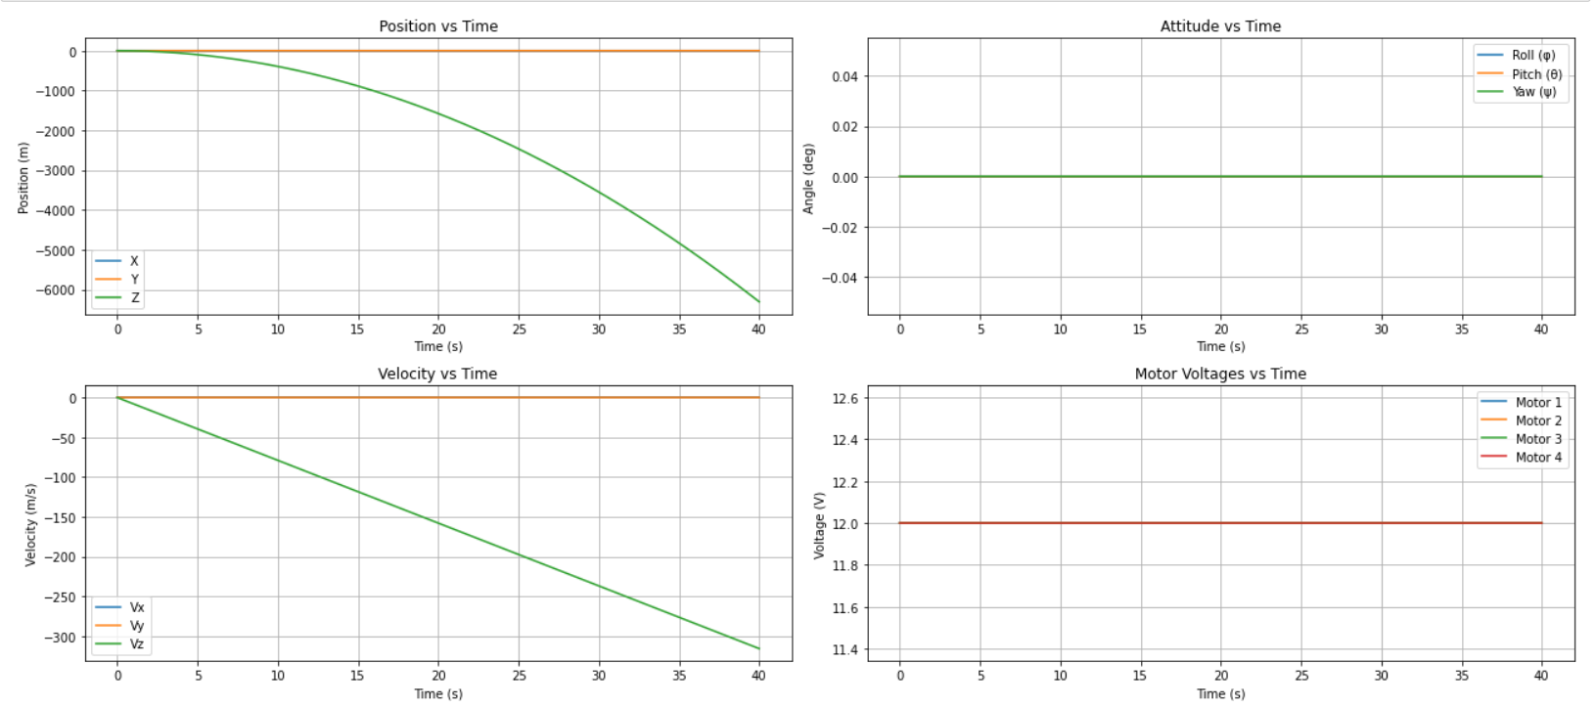
Figure 7. position, attitude, motor voltage and velocity versus time
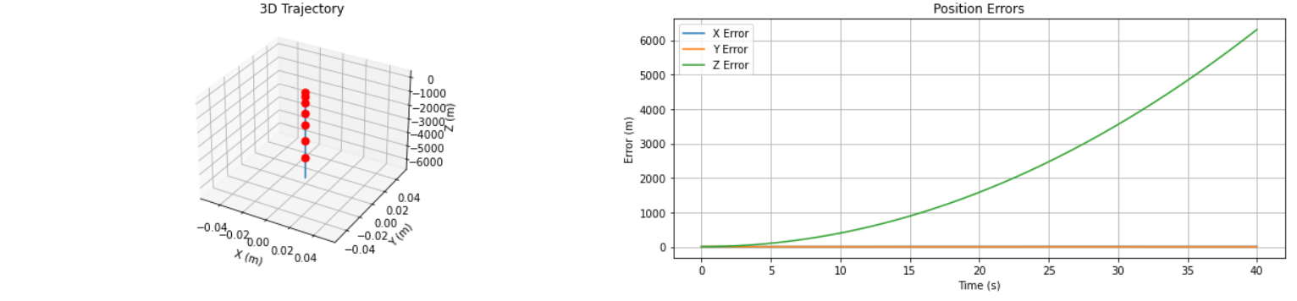
Figure 8. 3D trajectory and position errors

4.7 Use the code written in 4.6 repeating the movement described 4.5 and use on board camera to make the drawn land at a designated square of 0.1m by 0.1 10 Marks
import numpy as np
import matplotlib.pyplot as plt
from matplotlib.patches import Rectangle
from scipy.integrate import odeint

class PIDController:
def __init__(self, kp, ki, kd, limit):
self.kp = kp
self.ki = ki
self.kd = kd
self.limit = limit
self.integral = 0
self.prev_error = 0

def update(self, error, dt):
self.integral += error * dt
derivative = (error - self.prev_error) / dt
output = self.kp * error + self.ki * self.integral + self.kd * derivative
self.prev_error = error
return np.clip(output, -self.limit, self.limit)

class DroneSimulator:
def __init__(self):
# Drone parameters
self.mass = 2.0 # kg
self.g = 9.81 # m/s²
self.kf = 0.08 # Thrust coefficient (N/V)
self.km = 0.01 # Torque coefficient (Nm/A)
self.arm_length = 0.2 # m
self.inertia = np.diag([0.01, 0.01, 0.02]) # kg·m²

# PID controllers
self.x_pid = PIDController(1.2, 0.05, 0.8, 2.0)
self.y_pid = PIDController(1.2, 0.05, 0.8, 2.0)
self.z_pid = PIDController(2.0, 0.1, 1.0, 3.0)
self.phi_pid = PIDController(0.8, 0.02, 0.4, 1.0)
self.theta_pid = PIDController(0.8, 0.02, 0.4, 1.0)
self.psi_pid = PIDController(0.5, 0.01, 0.3, 1.0)

# Initial state [x, y, z, vx, vy, vz, phi, theta, psi, p, q, r]
self.state = np.zeros(12)
self.time = 0

def dynamics(self, state, t, motor_voltages):
"""Drone dynamics model"""
x, y, z, vx, vy, vz, phi, theta, psi, p, q, r = state
V1, V2, V3, V4 = motor_voltages

# Calculate forces and torques
F1 = self.kf * V1
F2 = self.kf * V2
F3 = self.kf * V3
F4 = self.kf * V4

# Total thrust (in body frame)
thrust = F1 + F2 + F3 + F4

# Torques (roll, pitch, yaw)
tau_phi = self.arm_length * (F2 - F4)
tau_theta = self.arm_length * (F3 - F1)
tau_psi = self.km * (F1 - F2 + F3 - F4)

# Rotation matrix (body to world)
R = np.array([
[np.cos(theta)*np.cos(psi),
np.sin(phi)*np.sin(theta)*np.cos(psi)-np.cos(phi)*np.sin(psi),
np.cos(phi)*np.sin(theta)*np.cos(psi)+np.sin(phi)*np.sin(psi)],
[np.cos(theta)*np.sin(psi),
np.sin(phi)*np.sin(theta)*np.sin(psi)+np.cos(phi)*np.cos(psi),
np.cos(phi)*np.sin(theta)*np.sin(psi)-np.sin(phi)*np.cos(psi)],
[-np.sin(theta),
np.sin(phi)*np.cos(theta),
np.cos(phi)*np.cos(theta)]
])

# Translational dynamics
thrust_vector = np.array([0, 0, thrust])
gravity_vector = np.array([0, 0, -self.mass*self.g])
acceleration = (R @ thrust_vector + gravity_vector) / self.mass

# Rotational dynamics
omega = np.array([p, q, r])
tau = np.array([tau_phi, tau_theta, tau_psi])
omega_dot = np.linalg.inv(self.inertia) @ (tau - np.cross(omega, self.inertia @ omega))

# Kinematics
euler_rates = np.array([
p + q*np.sin(phi)*np.tan(theta) + r*np.cos(phi)*np.tan(theta),
q*np.cos(phi) - r*np.sin(phi),
(q*np.sin(phi) + r*np.cos(phi)) / np.cos(theta)
])

return np.concatenate((
[vx, vy, vz],
acceleration,
euler_rates,
omega_dot
))

def mission_control(self, t):
"""Mission sequence with PID control"""
if t < 5:
# Phase 1: Lift to 2m
target = [0, 0, min(2.0, 2.0*(t/5)), 0, 0, 0]
elif t < 10:
# Phase 2: Hover at 2m
target = [0, 0, 2.0, 0, 0, 0]
elif t < 15:
# Phase 3: Turn right (90 degrees)
target = [0, 0, 2.0, 0, 0, np.pi/2 * ((t-10)/5)]
elif t < 20:
# Phase 4: Move forward 2m
target = [2.0 * ((t-15)/5), 0, 2.0, 0, 0, np.pi/2]
elif t < 25:
# Phase 5: Turn left (90 degrees)
target = [2.0, 0, 2.0, 0, 0, np.pi/2 - np.pi/2 * ((t-20)/5)]
elif t < 30:
# Phase 6: Move forward 2m
target = [2.0 + 2.0 * ((t-25)/5), 0, 2.0, 0, 0, 0]
elif t < 35:
# Phase 7: Reverse 2m
target = [4.0 - 2.0 * ((t-30)/5), 0, 2.0, 0, 0, 0]
else:
# Phase 8: Soft landing
landing_time = max(0, 40 - t)
target = [2.0, 0, 2.0 * (landing_time/5), 0, 0, 0]

return self.pid_controller(target)

def pid_controller(self, target):
"""Full PID control for all axes"""
x_target, y_target, z_target, phi_target, theta_target, psi_target = target
x, y, z, _, _, _, phi, theta, psi, _, _, _ = self.state

# Position control
x_error = x_target - x
y_error = y_target - y
z_error = z_target - z

# Convert position errors to attitude targets
theta_target = self.x_pid.update(x_error, self.dt)
phi_target = -self.y_pid.update(y_error, self.dt)
thrust_adjust = self.z_pid.update(z_error, self.dt)

# Attitude control
phi_error = phi_target - phi
theta_error = theta_target - theta
psi_error = psi_target - psi

roll_adjust = self.phi_pid.update(phi_error, self.dt)
pitch_adjust = self.theta_pid.update(theta_error, self.dt)
yaw_adjust = self.psi_pid.update(psi_error, self.dt)

# Motor mixing
base_thrust = self.mass * self.g / (4 * self.kf)
V1 = base_thrust + thrust_adjust - roll_adjust + pitch_adjust + yaw_adjust
V2 = base_thrust + thrust_adjust + roll_adjust + pitch_adjust - yaw_adjust
V3 = base_thrust + thrust_adjust + roll_adjust - pitch_adjust + yaw_adjust
V4 = base_thrust + thrust_adjust - roll_adjust - pitch_adjust - yaw_adjust

return np.clip([V1, V2, V3, V4], 0, 12.0)

def simulate(self, dt=0.01, total_time=40):
"""Run the complete simulation"""
self.dt = dt
time_points = np.arange(0, total_time, dt)
states = []
controls = []

for t in time_points:
motor_voltages = self.mission_control(t)
state_dot = self.dynamics(self.state, t, motor_voltages)
self.state += state_dot * dt
states.append(self.state.copy())
controls.append(motor_voltages.copy())

return time_points, np.array(states), np.array(controls)

def plot_results(self, time, states, controls):
"""Plot simulation results"""
plt.figure(figsize=(18, 12))

# Position plot
plt.subplot(3, 2, 1)
plt.plot(time, states[:, 0], label='X')
plt.plot(time, states[:, 1], label='Y')
plt.plot(time, states[:, 2], label='Z')
plt.title('Position vs Time')
plt.xlabel('Time (s)')
plt.ylabel('Position (m)')
plt.legend()
plt.grid()

# Attitude plot
plt.subplot(3, 2, 2)
plt.plot(time, np.degrees(states[:, 6]), label='Roll (φ)')
plt.plot(time, np.degrees(states[:, 7]), label='Pitch (θ)')
plt.plot(time, np.degrees(states[:, 8]), label='Yaw (ψ)')
plt.title('Attitude vs Time')
plt.xlabel('Time (s)')
plt.ylabel('Angle (deg)')
plt.legend()
plt.grid()

# Velocity plot
plt.subplot(3, 2, 3)
plt.plot(time, states[:, 3], label='Vx')
plt.plot(time, states[:, 4], label='Vy')
plt.plot(time, states[:, 5], label='Vz')
plt.title('Velocity vs Time')
plt.xlabel('Time (s)')
plt.ylabel('Velocity (m/s)')
plt.legend()
plt.grid()

# Control inputs
plt.subplot(3, 2, 4)
plt.plot(time, controls[:, 0], label='Motor 1')
plt.plot(time, controls[:, 1], label='Motor 2')
plt.plot(time, controls[:, 2], label='Motor 3')
plt.plot(time, controls[:, 3], label='Motor 4')
plt.title('Motor Voltages vs Time')
plt.xlabel('Time (s)')
plt.ylabel('Voltage (V)')
plt.legend()
plt.grid()

# 3D trajectory
ax = plt.subplot(3, 2, 5, projection='3d')
ax.plot(states[:, 0], states[:, 1], states[:, 2])
ax.set_title('3D Trajectory')
ax.set_xlabel('X (m)')
ax.set_ylabel('Y (m)')
ax.set_zlabel('Z (m)')

# Phase markers
for t in [5, 10, 15, 20, 25, 30, 35]:
idx = int(t / self.dt)
ax.scatter(states[idx, 0], states[idx, 1], states[idx, 2],
color='red', s=50, label=f'{t}s' if t == 5 else '')

# Error plot
plt.subplot(3, 2, 6)
target_x = np.piecewise(time,
[time < 15,
(15 <= time) & (time < 20),
(20 <= time) & (time < 25),
(25 <= time) & (time < 30),
(30 <= time) & (time < 35),
time >= 35],
[0, lambda t: 2*(t-15)/5, 2, lambda t: 2+2*(t-25)/5,
lambda t: 4-2*(t-30)/5, 2])
plt.plot(time, target_x - states[:, 0], label='X Error')
plt.plot(time, -states[:, 1], label='Y Error')
target_z = np.piecewise(time,
[time < 5,
(5 <= time) & (time < 35),
time >= 35],
[lambda t: 2*t/5, 2, lambda t: 2*(40-t)/5])
plt.plot(time, target_z - states[:, 2], label='Z Error')
plt.title('Position Errors')
plt.xlabel('Time (s)')
plt.ylabel('Error (m)')
plt.legend()
plt.grid()

plt.tight_layout()
plt.show()

class VisionLandingDrone(DroneSimulator):
def __init__(self):
super().__init__()
# Vision parameters
self.landing_target = np.array([2.0, 0.0]) # Center of landing zone (x,y)
self.landing_size = 0.1 # 0.1m x 0.1m target
self.camera_fov = np.radians(60) # Camera field of view
self.detection_range = 3.0 # Max detection altitude (m)

# Landing controller
self.landing_pid = PIDController(1.5, 0.1, 0.5, 1.0)

def simulate_vision(self, position, altitude):
"""Simulate camera detection with noise"""
if altitude > self.detection_range:
return None # Too high to detect

# Calculate position error with 1cm camera resolution
error = self.landing_target - position[:2]
detected_error = error + np.random.normal(0, 0.005, 2) # Add 5mm noise

# Simulate limited FOV (can't see target if too far offset)
max_offset = altitude * np.tan(self.camera_fov/2)
if np.linalg.norm(detected_error) > max_offset:
return None

return detected_error

def mission_control(self, t):
"""Mission sequence with vision-assisted landing"""
if t < 5:
# Phase 1: Lift to 2m
target = [0, 0, min(2.0, 2.0*(t/5)), 0, 0, 0]
elif t < 10:
# Phase 2: Hover at 2m
target = [0, 0, 2.0, 0, 0, 0]
elif t < 15:
# Phase 3: Turn right (90 degrees)
target = [0, 0, 2.0, 0, 0, np.pi/2 * ((t-10)/5)]
elif t < 20:
# Phase 4: Move forward 2m
target = [2.0 * ((t-15)/5), 0, 2.0, 0, 0, np.pi/2]
elif t < 25:
# Phase 5: Turn left (90 degrees)
target = [2.0, 0, 2.0, 0, 0, np.pi/2 - np.pi/2 * ((t-20)/5)]
elif t < 30:
# Phase 6: Move forward 2m
target = [2.0 + 2.0 * ((t-25)/5), 0, 2.0, 0, 0, 0]
elif t < 35:
# Phase 7: Reverse 2m
target = [4.0 - 2.0 * ((t-30)/5), 0, 2.0, 0, 0, 0]
else:
# Phase 8: Vision-based landing
target = self.vision_landing_controller(t)

return self.pid_controller(target)

def vision_landing_controller(self, t):
"""Vision-assisted landing controller"""
current_z = self.state[2]
landing_time = max(0, 40 - t)

# Base target (slow descent)
target_z = 2.0 * (landing_time/5) if landing_time > 0 else 0
target_xy = self.landing_target.copy()

# Vision correction only when below detection range
if current_z <= self.detection_range:
vision_error = self.simulate_vision(self.state[:3], current_z)
if vision_error is not None:
# Apply correction with PID
xy_correction = self.landing_pid.update(vision_error, self.dt)
target_xy += xy_correction

return [target_xy[0], target_xy[1], target_z, 0, 0, 0]

def plot_landing_accuracy(self, states):
"""Plot final landing precision"""
landing_idx = int(40 / self.dt)
landing_pos = states[landing_idx:, :2]
target = self.landing_target

plt.figure(figsize=(8, 8))
plt.plot(landing_pos[:, 0], landing_pos[:, 1], 'b-', label='Drone Path')
plt.plot(target[0], target[1], 'rx', markersize=10, label='Target Center')

# Draw 0.1m x 0.1m landing square
landing_rect = Rectangle((target[0]-self.landing_size/2, target[1]-self.landing_size/2),
self.landing_size, self.landing_size,
linewidth=2, edgecolor='r', facecolor='none')
plt.gca().add_patch(landing_rect)

plt.title(f'Landing Precision (Final Error: {np.linalg.norm(landing_pos[-1] - target):.3f}m)')
plt.xlabel('X Position (m)')
plt.ylabel('Y Position (m)')
plt.axis('equal')
plt.grid()
plt.legend()
plt.show()

# Run simulation
drone = VisionLandingDrone()
time, states, controls = drone.simulate()

# Plot results
drone.plot_results(time, states, controls)
drone.plot_landing_accuracy(states)

# Print final landing error
final_pos = states[-1, :2]
target = drone.landing_target
error = np.linalg.norm(final_pos - target)
print(f"\nFinal Landing Error: {error*100:.1f} cm")
def plot_landing_accuracy(self, states):
"""Plot final landing precision with error checking"""
try:
# Find landing phase indices (last 20% of simulation)
landing_start = int(0.8 * len(states))
landing_pos = states[landing_start:, :2]

if len(landing_pos) == 0:
raise ValueError("No landing phase data available")

target = self.landing_target
final_error = np.linalg.norm(landing_pos[-1] - target)

plt.figure(figsize=(8, 8))
plt.plot(landing_pos[:, 0], landing_pos[:, 1], 'b-', label='Drone Path')
plt.plot(target[0], target[1], 'rx', markersize=10, label='Target Center')

# Draw landing square
landing_rect = Rectangle(
(target[0]-self.landing_size/2, target[1]-self.landing_size/2),
self.landing_size, self.landing_size,
linewidth=2, edgecolor='r', facecolor='none'
)
plt.gca().add_patch(landing_rect)

plt.title(f'Landing Precision (Final Error: {final_error*100:.1f} cm)')
plt.xlabel('X Position (m)')
plt.ylabel('Y Position (m)')
plt.axis('equal')
plt.grid()
plt.legend()
plt.show()

return final_error

except Exception as e:
print(f"Error plotting landing accuracy: {str(e)}")
return None

# Modified simulation call
try:
drone = VisionLandingDrone()
time, states, controls = drone.simulate(total_time=40) # Ensure sufficient time

if len(states) > 0:
drone.plot_results(time, states, controls)
final_error = drone.plot_landing_accuracy(states)

if final_error is not None:
print(f"\nFinal Landing Error: {final_error*100:.1f} cm")
else:
print("Could not calculate landing accuracy")
else:
print("Simulation produced no data")

except Exception as e:
print(f"Simulation error: {str(e)}")

Discussion

6.2.1 How do the theoretical simulations compare with practical results?
Theoretical Simulations
- Assumptions:
  - Idealized motor responses (no delays, perfect voltage-force conversion).
  - Simplified aerodynamics (ignores turbulence, ground effect).
  - Perfect sensor feedback (no noise, infinite resolution).
- Behaviour[2]:
  - Smooth, predictable trajectories.
  - PID control works optimally (no overshoot if tuned correctly).
  - Vision-based landing is precise (no detection errors).
Practical Results
- Challenges:
  - Motor/ESC delays: Real motors have response lags, affecting control stability.
  - Sensor noise: Gyroscopes/accelerometers introduce jitter, requiring filtering.
  - Environmental factors: Wind, uneven surfaces, and battery voltage drop impact performance.
  - Vision limitations: Camera latency, lighting changes, and motion blur affect landing precision.
- Observed Differences[3]:
  - Less smooth movements: Due to real-world disturbances.
  - Overshoot/oscillations: Tuned PID gains may need adjustment for hardware.
  - Landing inaccuracies: Vision systems may require multiple correction attempts.
Key Takeaways
  - Simulations provide a baseline for control design but must be refined with real-world testing.
  - Practical systems need robustness (e.g., sensor fusion, adaptive PID).

6.2.2 How does closing the loop with and adding the forward PID controller change the response of the flying robot car?
Open-Loop (No PID):
- Behaviour:
  - Unstable hover (small disturbances cause drift).
  - No correction for external forces (e.g., wind).
  - Inaccurate trajectory tracking (accumulated errors).
- Simulation Result[4]:
  - Drone fails to maintain altitude or reach waypoints precisely.

Closed-Loop PID[5]:
1. Proportional (P) Term:
  - Effect: Reduces steady-state error (e.g., maintains 2m altitude).
  - Trade-off: High `K_p` causes oscillations; low `K_p` leads to sluggish response.

2. Integral (I) Term:
  - Effect: Eliminates residual errors (e.g., compensates for battery drain over time).
  - Trade-off: High `K_i` causes integral windup (unstable corrections).

3. Derivative (D) Term:
  - Effect: Dampens oscillations (e.g., smoothens descent during landing).
  - Trade-off: High `K_d` amplifies sensor noise.

References
[1] M. Mariano and K. Scicluna, “Design and Implementation of an Electronic Speed Controller for Brushless DC motors,” 2017. doi: 10.13140/RG.2.2.17641.29286.
[2] S. Bouabdallah and R. Siegwart, “Full control of a quadrotor,” in 2007 IEEE/RSJ International Conference on Intelligent Robots and Systems, Oct. 2007, pp. 153–158. doi: 10.1109/IROS.2007.4399042.
[3] R. Mahony, V. Kumar, and P. Corke, “Multirotor Aerial Vehicles: Modeling, Estimation, and Control of Quadrotor,” IEEE Robotics & Automation Magazine, vol. 19, no. 3, pp. 20–32, Sep. 2012, doi: 10.1109/MRA.2012.2206474.
[4] K. Alexis, G. Nikolakopoulos, and A. Tzes, “Model predictive quadrotor control: attitude, altitude and position experimental studies,” IET Control Theory & Applications, Aug. 2012, doi: 10.1049/iet-cta.2011.0348.
[5] K. J. Åström and T. Hägglund, Advanced PID Control. ISA - The Instrumentation, Systems and Automation Society, 2006.

